05th October 2026
Ms. Vaishnavi N
Reg. No: 113824243010
Sri Jayaram Institute of Engineering and Technology,

Elavur.

Dear Vaishnavi,
We are pleased to offer you a position in the Program - Technical Internship at Gradtwin Services. The duration of the program will be 3 months from October 2026 to December 2026, commencing from your training start date.
The CodeNerds Program is designed to provide hands-on, real-time technical exposure to help you strengthen your practical knowledge, problem-solving abilities, and industry readiness.
During this program, we expect you to maintain professionalism, dedication, and responsibility while representing our organization with integrity. In return, we assure you guidance, mentoring, and continuous support throughout your learning journey.
Please note that this program is focused entirely on practical, hands-on experience. However, upon successful completion, you will receive the following:
- Certificate of Completion – CodeNerds Program
- Letter of Recommendation
- Recognition & Rewards for Top Performers
We are delighted to have you join the CodeNerds Program and look forward to seeing your growth and contributions.
For Gradtwin Services (OPC) Private Limited
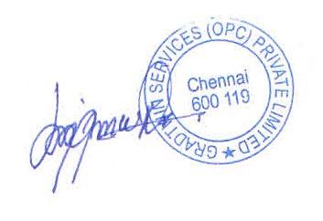

Kanishrajiah Durairaju

Manager - Human Resource

